TASK1:

Section 1: Core Command Operations

1. Directory Navigation & File Handling
Script:
# Make directories and files
mkdir -p ~/SysOpsLab/Exercises/SessionA
touch ~/SysOpsLab/Exercises/SessionA/{alpha,beta,gamma}.txt

# Moving , copying , renaming
mkdir -p ~/SysOpsLab/Archives/
mv ~/SysOpsLab/Exercises/SessionA/alpha.txt ~/SysOpsLab/Archives/
cp ~/SysOpsLab/Exercises/SessionA/beta.txt ~/SysOpsLab/
mv ~/SysOpsLab/Exercises/SessionA/gamma.txt ~/SysOpsLab/Exercises/SessionA/delta.txt

#For screenshot output
ls -R ~/SysOpsLab && ls -li ~/SysOpsLab/Archives/
Screenshot:
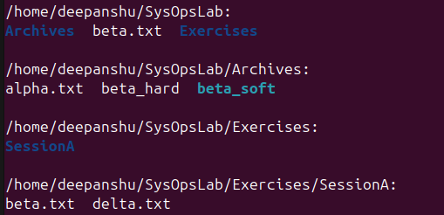

2. File Permissions and Ownership
Script:
# Create file & restrict permissions
touch private_log.txt
chmod 600 private_log.txt
ls -l private_log.txt

# Bonus: ACL
sudo apt install acl -y
sudo setfacl -m u:nobody:r private_log.txt
getfacl private_log.txt
Screenshot:
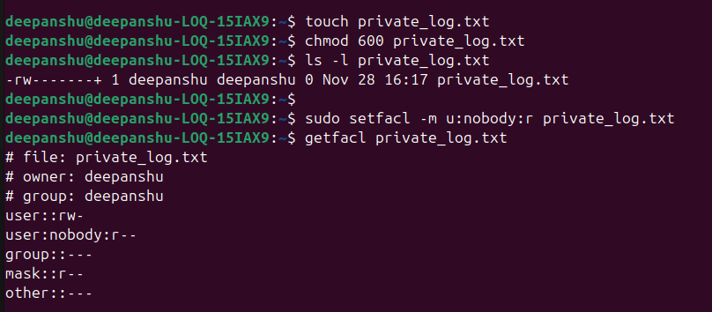

3. System Status & Resource Information
Script:
#Generate the report
echo "--- SYSTEM REPORT $(date) ---" > sysinfo_report.txt
echo "User: $(whoami)" >> sysinfo_report.txt
echo "Uptime: $(uptime)" >> sysinfo_report.txt
echo "Memory: $(free -h | grep Mem)" >> sysinfo_report.txt
echo "Kernel: $(uname -r)" >> sysinfo_report.txt

# For displaying
cat sysinfo_report.txt
Screenshot:
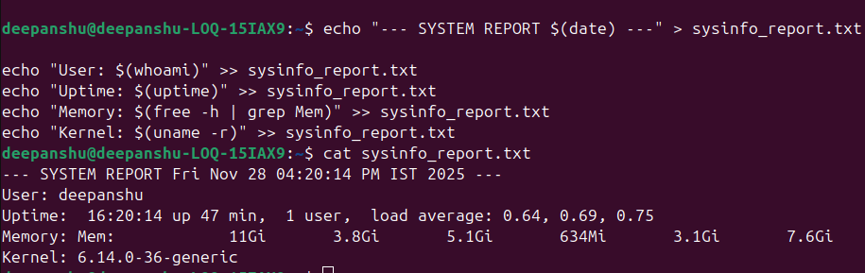

Section 2: User, Group & Permission Management

4. User and Group Administration
Scripts:
# Creates user and group
sudo useradd analyst1
sudo groupadd datateam
sudo usermod -aG datateam analyst1

sudo mkdir /datahub
sudo chown :datateam /datahub
sudo chmod 2770 /datahub

# Verify
ls -ld /datahub && id analyst1
Screenshot:
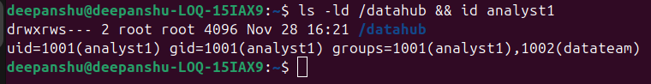

5. File Security and Auditing
Script:
# Setup vault
mkdir -p ~/secure_vault
chmod 700 ~/secure_vault

# install & enable audit
sudo apt install auditd -y
sudo auditctl -w ~/secure_vault -p wa -k vault_watch

# Resukt
sudo auditctl -l
Screenshot:
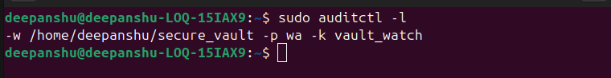

Section 3: Networking and Connectivity

6. Network Diagnostics
Script:
# Ping & IP
ping -c 3 google.com > netcheck.txt
ip a | grep "inet "

Screenshot:
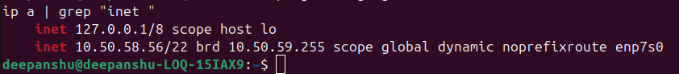

Section 4: Shell Scripting and Automation

7. File Checker Script
Script:
#!/bin/bash

LOG_FILE="inspector_log.txt"

log_action() {
local message="$1"
echo "$(date '+%Y-%m-%d %H:%M:%S') - $message" >> "$LOG_FILE"
}
echo "Please enter the filename to check:"
read filename

if [ -f "$filename" ]; then
echo "File found."
log_action "Checked '$filename': File existed."
else
touch "$filename"
echo "File created."
log_action "Checked '$filename': File not found. Created new file."
fi
Screenshot:
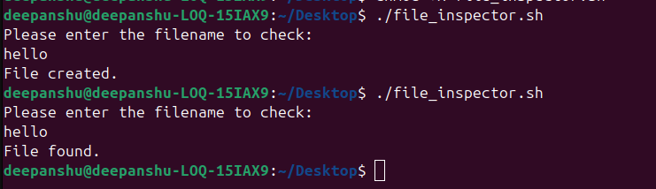

8. System Monitoring Script
Script:
#!/bin/bash

LOG_FILE=~/SysOpsLab/system_status.log

echo "========================================" >> "$LOG_FILE"
echo "Record Time: $(date)" >> "$LOG_FILE"

echo "--- Uptime ---" >> "$LOG_FILE"
uptime -p >> "$LOG_FILE"

echo "--- CPU Load ---" >> "$LOG_FILE"
cat /proc/loadavg >> "$LOG_FILE"

echo "--- Memory ---" >> "$LOG_FILE"
free -h >> "$LOG_FILE"

echo "--- Disk Usage ---" >> "$LOG_FILE"
df -h / >> "$LOG_FILE"

echo "Log updated successfully."
Screenshot:
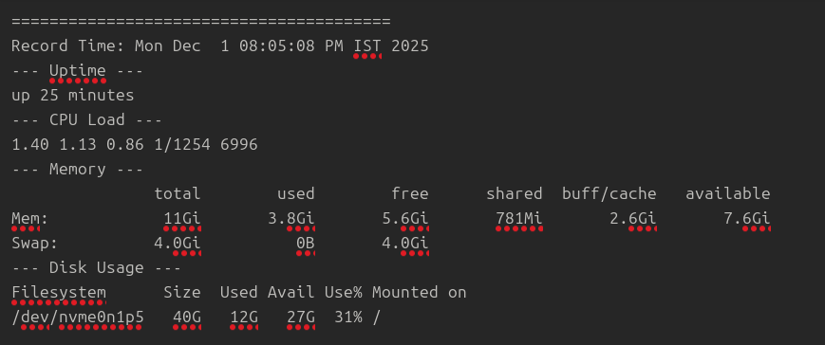

Section 5: Software and Process Management

9. Package Operations
Script:
sudo apt update && sudo apt upgrade -y
sudo apt install htop -y

apt list --installed > pkg_list.txt
Screenshot:
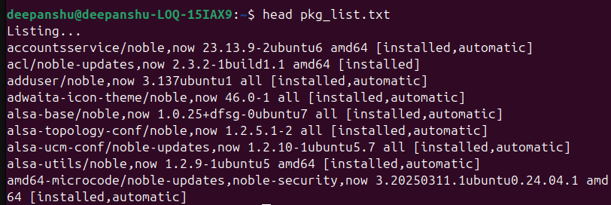

10. Process and Service Control
Script:
ps aux
top -o %CPU
sudo systemctl restart ssh
sudo systemctl status ssh

Screenshot:
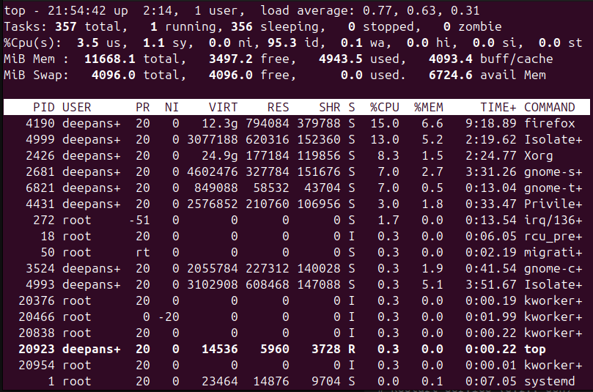

Section 6: Web Hosting and Security

11. Web Server Setup
Script:
sudo apt install apache2 -y
sudo systemctl start apache2
sudo systemctl enable apache2
echo "<html><h1>Welcome to My SysOps Lab</h1></html>" | sudo tee /var/www/html/index.html
Screenshot:

Section 7: Backup and Recovery

12. Automated Backup Script
Script:
#!/bin/bash

SOURCE_DIR=~/SysOpsLab
BACKUP_DIR=~/Backups
LOG_FILE=~/backup_log.txt
DATE_FORMAT=$(date +%Y%m%d_%H%M)
ARCHIVE_NAME="backup_$DATE_FORMAT.tar.gz"

mkdir -p "$BACKUP_DIR"

# tar flags: c=create, z=gzip, f=filename
echo "Starting backup for $SOURCE_DIR..." >> "$LOG_FILE"

tar -czf "$BACKUP_DIR/$ARCHIVE_NAME" "$SOURCE_DIR" 2>/dev/null

if [ $? -eq 0 ]; then
echo "$(date): Backup successful: $ARCHIVE_NAME" >> "$LOG_FILE"
else
echo "$(date): Backup FAILED" >> "$LOG_FILE"
fi

echo "Cleanup complete. Old backups removed." >> "$LOG_FILE"

Screenshot:

Section 8: Text Processing & File Manipulation

13. Text Utilities Practice
Script:
Screenshot:
